1. The Deductive Path: "Rule to Example"
The deductive approach starts with the generalized formula or principle and moves toward specific applications. This is the traditional "top-down" method often seen in university lectures.

When it is most effective:
- High Complexity, Low Time: If a formula (like the Navier-Stokes equations) is mathematically dense and requires hours to derive, a deductive start saves time by establishing the "what" before the "why."
- Expert Learners: Students with a strong foundational schema can quickly integrate a new formula into their existing knowledge base without needing a "discovery" phase.
- Safety-Critical Procedures: When teaching formulas related to structural integrity or electrical load limits, clarity and precision are paramount. Deductive teaching reduces the risk of students "discovering" a wrong or dangerous version of a principle.
The Flow: State the Formula → Define Variables → Show Worked Examples → Student Practice.

2. The Inductive Path: "Example to Rule"
The inductive approach is "bottom-up." It starts with specific observations, data, or experiments and leads the student to "discover" the formula.

When it is most effective:
- Conceptual "Aha!" Moments: Inductive paths are superior when the formula describes a tangible physical relationship, such as Hooke’s Law (F=kx). By stretching springs of different stiffnesses, students "feel" the relationship before seeing the math.
- Long-term Retention: Because the student has to actively construct the logic, the neural pathways formed are generally stronger. This is excellent for core engineering concepts that serve as building blocks for later years.
- Developing Problem-Solving Intuition: It teaches students how to look at raw data and identify patterns—a crucial skill for R&D (Research & Development) engineering.
The Flow: Observe Phenomenon → Collect Data → Identify Patterns → Formalize the Formula.

3. Comparative Analysis for Engineering Education
Feature | Inductive Path | Deductive Path
Cognitive Load | High (Initial struggle) | Low (Initial clarity)
Student Role | Active Explorer | Receptive Learner
Best For | Discovery of basic laws | Application of complex math
Risk | Misconceptions during discovery | Rote memorization without "soul"
Time Req. | Significant | Minimal
Export to Sheets

4. The Synthesis: The "Sandwich" Method
In modern engineering pedagogy, the most effective strategy is often a hybrid.
- Inductive Hook: Start with a brief, intriguing problem or simulation (e.g., "Why did this bridge vibrate?").
- Deductive Delivery: Introduce the formal complex formula (e.g., resonance and damping equations) to explain the observation.
- Inductive Extension: Have students apply the formula to a new, slightly different scenario to test the boundaries of the rule.
In Computer Science, the choice between inductive and deductive paths is often dictated by the "level of abstraction"—whether you are teaching low-level machine logic or high-level algorithmic theory.

1. The Inductive Path in CS: "Bottom-Up"
This is most effective when teaching algorithmic patterns and data structures. Because CS is fundamentally about pattern recognition, starting with specific cases helps students build a mental model of how data moves.

When to use it:
- Recursive Formulas: Instead of starting with the recurrence relation for Merge Sort:
T(n)=2T(n/2)+n
Start by having students manually sort 2 cards, then 4, then 8. Let them "discover" that the work doubles and requires a merge step.
- Machine Learning: Before introducing a Loss Function formula, show students a scatter plot and ask them to draw a line that "looks" right. This builds the intuition behind minimizing error.
- Design Patterns: Show three different "messy" code snippets that solve similar problems. Have students identify the common structure before naming it (e.g., the Factory Pattern).

2. The Deductive Path in CS: "Top-Down"
This is most effective for Systems Architecture, Complexity Theory, and Formal Logic. When the rules are mathematical "laws of the universe," starting with the rule provides the necessary constraints for thought.
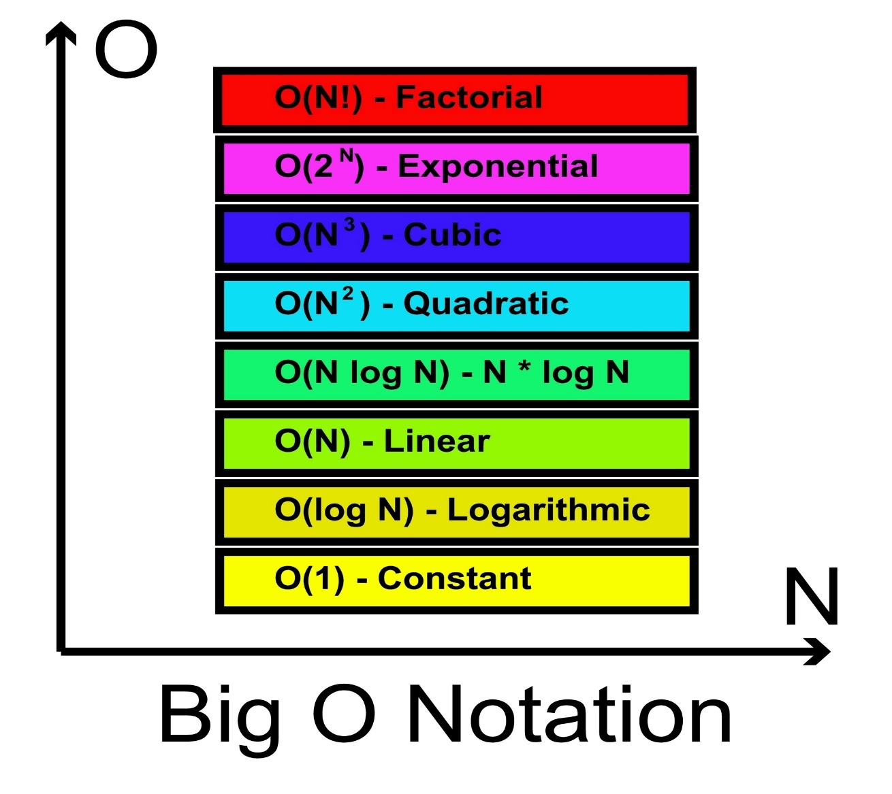

When to use it:
- Big O Notation: Complexity classes are easier to understand deductively. Define the hierarchy (O(1)<O(logn)<O(n)…) first, then analyze code to see where it fits.
- Protocol Standards: When teaching TCP/IP or Security Handshakes, the "rules" are arbitrary and man-made. There is no natural phenomenon to "discover," so you must state the protocol (the formula/rule) and then show it in action.
- Boolean Algebra: Start with the laws (e.g., De Morgan's Laws).
¬(A∧B)⟺(¬A)∨(¬B)
Once the law is established, students can use it to simplify complex if-else blocks in their code.

3. Cognitive Strategy: The "Sandbox" Approach
Computer Science offers a unique tool for these paths: the Compiler. Unlike civil engineering, where an "inductive" failure might break a physical bridge, CS students can fail safely.
Strategy | Path | CS Application
Trace-First | Inductive | Trace the execution of a loop with sample inputs to derive the loop invariant.
Theorem-First | Deductive | Use a known API or Library's documentation to build a specific feature.
Refactoring | Inductive | Write "ugly" working code first, then extract the generalized formula/function.
Export to Sheets

Summary of Effectiveness
- Use Inductive when you want to build intuition and "hacker" problem-solving skills. It works best for junior developers or when introducing a brand-new concept like Pointers.
- Use Deductive when you need efficiency and precision. It works best for senior students who need to optimize systems or verify that their code is mathematically "correct."
Are you currently designing a curriculum for a specific CS topic, like Algorithms, Systems, or Software Engineering?

